AD SERVER
Configuration for SCCM
Step 1:
Windows Server Roles of SCCM Install
- IIS (Internet Information Services)
- BITS (Background Intelligent Transfer Service)
- Remote Differential Compression
- WSUS (Windows Server Update Services) (optional)
- Windows Deployment Services (WDS) (optional)
- Ensure DNS is properly configured on DC.
- Optionally, set up DHCP to assign IPs dynamically.
Step 2:
System Management container
- ADSI Edit (adsiedit.msc)-> connect to the site server's domain-> Right-click CN=System->New-> Object-> Create Object window-> select Container-> Next.
- Value box, enter System Management-> Next.
- Right-click CN=System Management->Properties->Switch to the Security tab->Add->site server's computer account with the Full Control permission.
- Select Advanced, select the site server's computer account, and then select Edit.
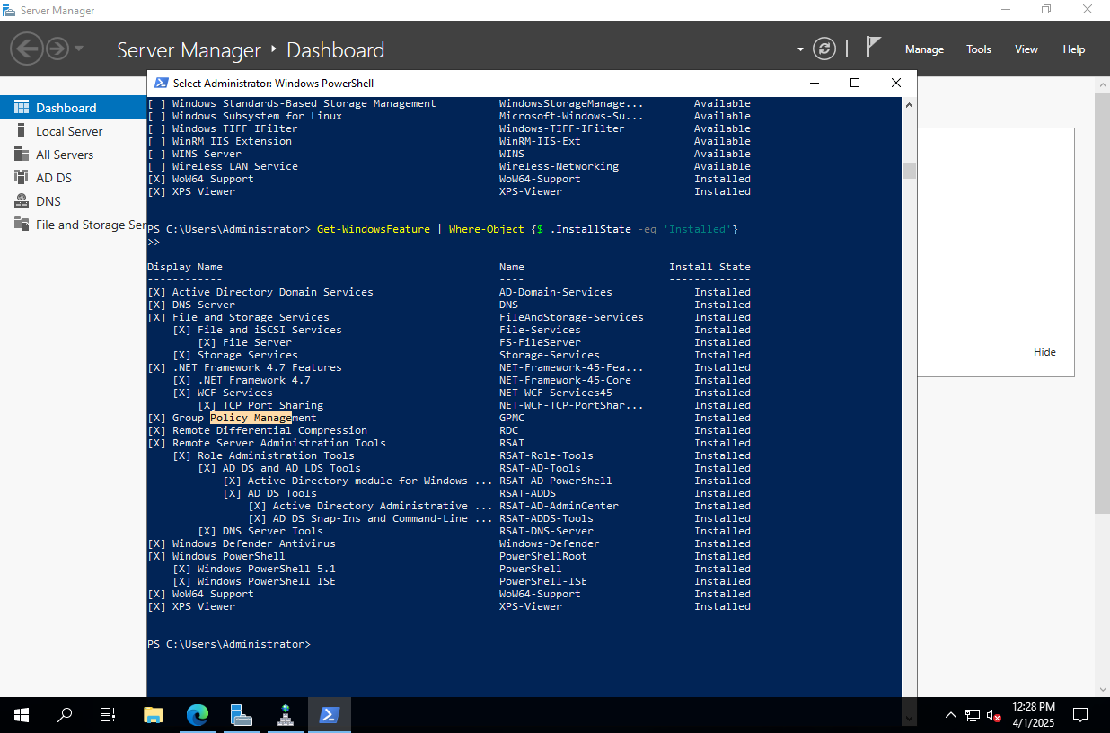
- In the Apply onto list, select This object and all descendant objects.
- Select OK to save the configuration.
Step 3:
Prepare Active Directory (AD) Schema
Extend Active Directory Schema for SCCM:
PowerShell
extadsch.exe /forestprep

Extend the schema
- Use an account that's a member of the Schema Admins security group.
- Use the extadsch.exe tool in SMSSETUP\BIN\X64
Cmd
cd X:\SMSSETUP\BIN\X64

Verify the schema extension by checking Logs in notepad
C:\extadsch.log

Step 4:
Create OU For SCCM users
